Collecting User Behavior Through Google Analytics (2nd Week January, 2023)

Website/SEO Assignments

NAME: Tahiya Rahman

horizontal line

# About the Data

The purpose of the paper is to find out trends in behavior for the top 10 most viewed pages collected. The data showed the top viewed pageviews and the most bounce, exit rates along with the average session time users spent on the sites. The user behavior analysis showed a decent interest in NSTEM internship page.

Comparison of Data over trends

Jan 15th, 2023-Jan 22nd, 2023

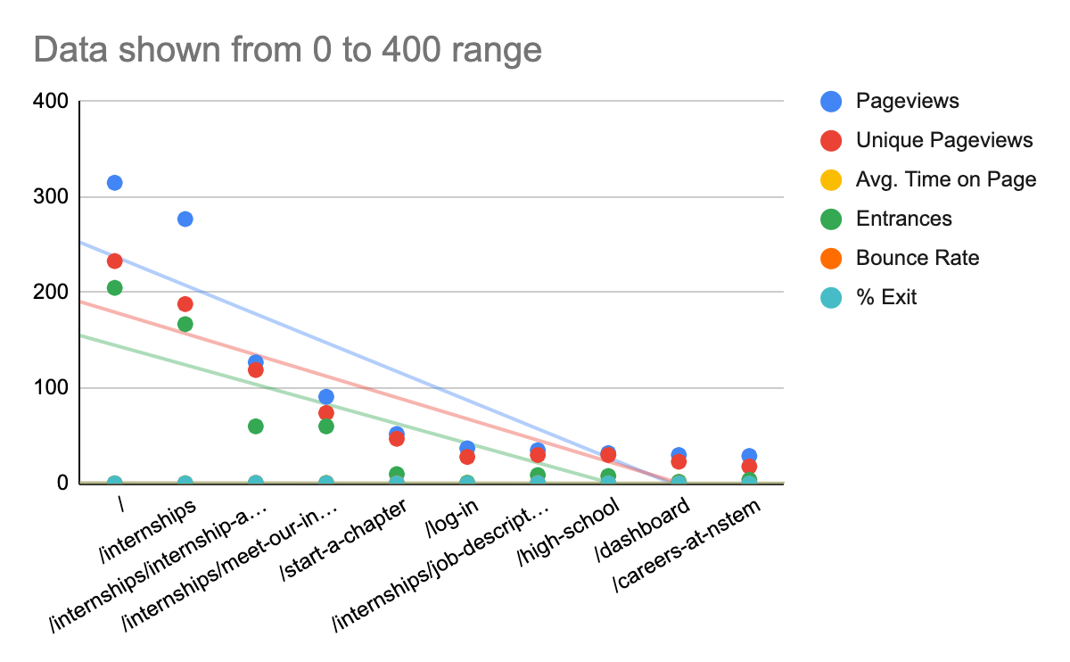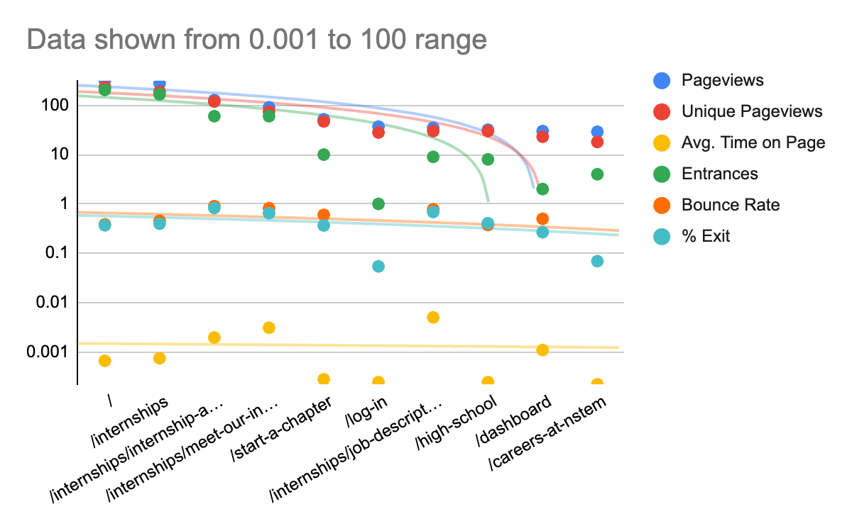

* As the data shown above, from behavior data the highest traffic generator audience **/internships** page from Pageviews, Unique pageviews, Entrance.
* The second trend considered to be the **/internships/meet-our-interns, /internships/job-descriptions-and-skills-required** and **/internships/internship-application** from Bounce rate, Exit and average time spent.
* All the data are positioned with the trendline. Trendline considered to be the threshold level where the investment decision and a potential trend to consider as a decent source of increasing users.

# What NSTEM Should Continue Doing

* NSTEM should continue to promote internships.
* NSTEM Should make partnerships with different software companies for the internship. Because the internships page shows the highest pageviews. So there are students who are seeking internships and within employment.

# Ways to Improve the Website

* As the bounce rate and exit rate, both were higher for the /internships/internship-application and /internships/meet-our-interns. NSTEM should create an easy Apply option in the website so the interns can save their time finding the options. Besides, meet our interns page can create a grid view where all the interns and their bio displays in a few pages and scrolls. Or make the bio a little shorter so the students can get some ideas and also feel the NSTEM is reliable and credible to work for the internships.

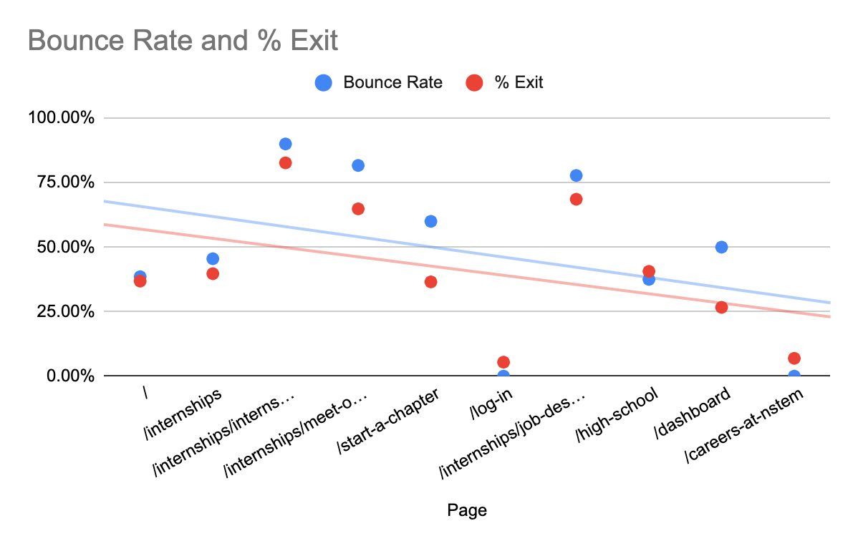

* NSTEM should create scope for hiring consultations, resume corrections and life coaches as well, student advisor, course analysis groups, workshops for the hiring opportunities.

# 

# 

# Data that Stands Out

From the analysis, the user behavior showed an interest towards the internship in NSTEM. NSTEM should create more visuals and a more convenient user interface for UX experience. Thus, students will be able to understand and navigate to apply for the internship easily.

# Conclusion

To conclude, the most potential trend factor was generated from the internship pages in NSTEM.

Google Sheets:

<https://docs.google.com/spreadsheets/d/1zWjA4d1j5ue6iWA6mNQCNOACXm5kDS3AP2-271PDvXQ/edit?usp=sharing>

Google data studio: <https://lookerstudio.google.com/reporting/2b53807a-0f21-4150-8f38-570386ad28b1>